GREAT LUNCHES START IN ORGANIZED PANTRIES

At INSPIRED CLOSETS PITTSBURGH we create pantries that work for how you live! Once you select a great lunch box you need to be able to fill it with all the healthy items sustain you throughout your day.

Here are some resources from Leslie’s Lunchbox Segment on KDKA Pittsburgh Today Live:
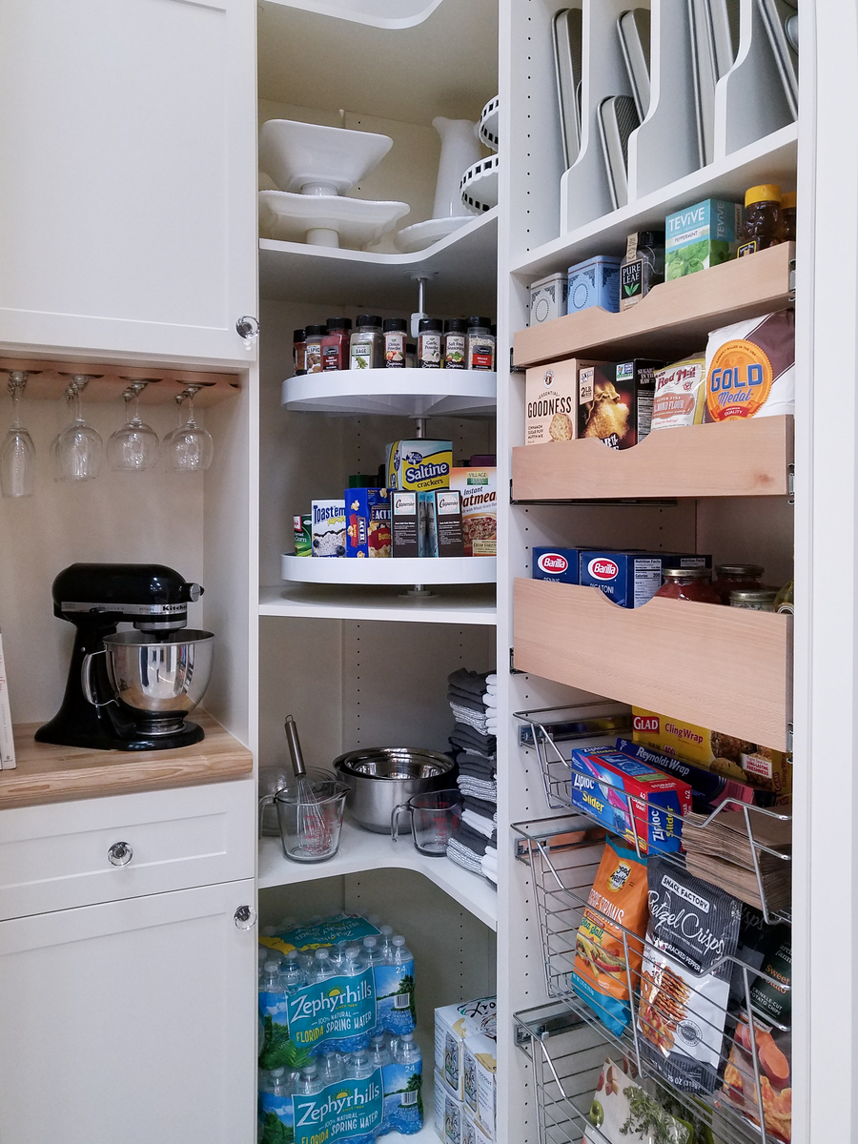
SMART PLANET COLLAPSABLE MEAL KIT
$12.99 at Bed Bath and Beyond

PACK IT FREEZABLE LUNCH BAG
$18.65 at Rolliers Hardware or Walmart

FIT FRESH MINI BENTO
$7.99 at Target

LOOK BACK BENTO BOX
$25.95 on Amazon

SAFER MEAL BENTO KIT
$25.75 on Amazon

JOKES for PACKING LUNCHES
Prepared Jokes for Lunch Boxes
$6.36 on Amazon

There are EIGHT ZONES that make up an organized pantry:

1. STAPLES – Rice, beans and pasta…
2. ON THE GO –napkins, lunch boxes, water bottles…
3. WEEK NIGHT MEALS – “go to” items that make up most of what you cook…
4. BAKING AND SPICES – sugar, flour, cinnamon…
5. KIDS AREA – a place for healthy snacks they can get for themselves…
6. GUEST TREAT – be prepared for a friend to pop in…
7. HOME REMEDIES – BRATS diet, teas, chicken noodle soup, simple meds…
8. HOLIDAYS – seasonal cooking items…

LET US HELP YOU DESIGN THE PANTRY YOU’VE BEEN DREAMING OF!
CALL US TODAY AT 412-443-4710

